Interaction Design

Lesson assignment 1.1

My everyday object: door handle on front door!

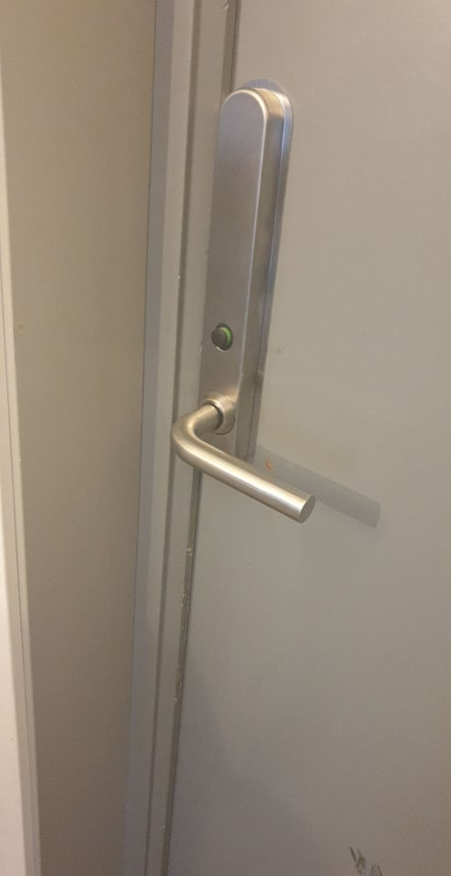 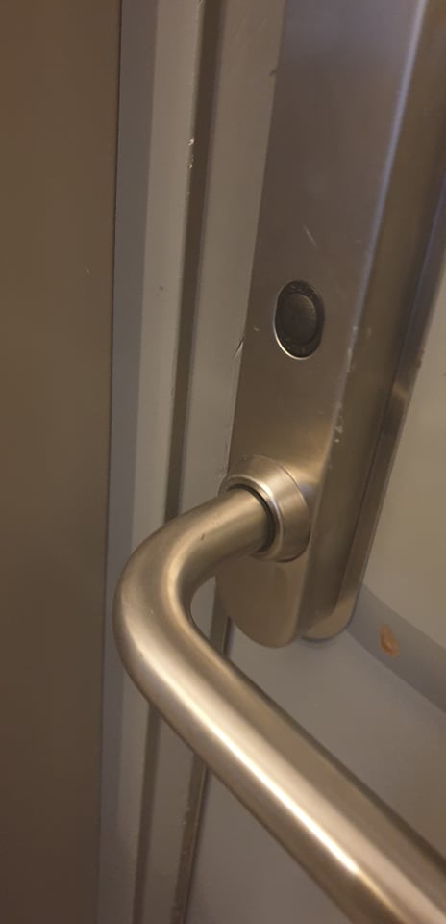

* My primary goals as a user of the door handle is to open and close the door

to keep it warm, among other things. My secondary goal is to lock the door from the inside and outside.

* Constraints of the product: when you pull down the handle from the inside, the door is unlocked (this is not lucky, as I have a 2 year old trying to go outside all the time).
* I like the design, especially where it shows that the door is unlocked with a green mark. I just want the lock to be opened in a way that a large child or adult can open it, I think maby they didn’t put a red mark (to show that the door is locked) to make the

design look more minimalistic.

* Yes I think they could have put a little red mark to indicate that the door is actually locked (when it is).